**Deploy, Upgrade and Rollback application using helm**

1. Execute Windows PowerShell and go to the Helm charts directory:

> *cd “E:\Kubernetes_Assignment_Advanced\Helm Charts”*

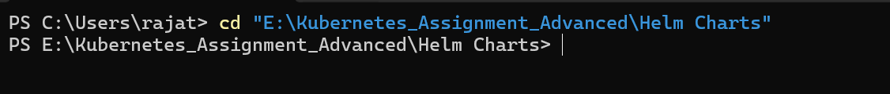

1. Create a namespace:

*> kubectl create ns userdataapp*



1. Deploy database helm chart (.\userdataapp_db_chart):

*> helm install userdataapp-db .\userdataapp_db_chart\ -n userdataapp*

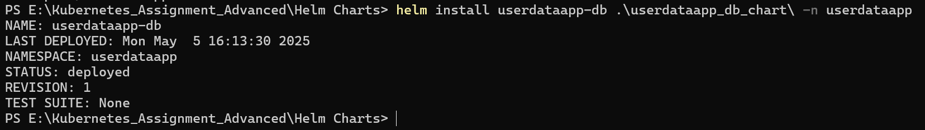

1. Deploy backend application helm chart(.\userdataapp_backend_chart):

*> helm install userdataapp-backend .\userdataapp_backend_chart\ -n userdataapp*

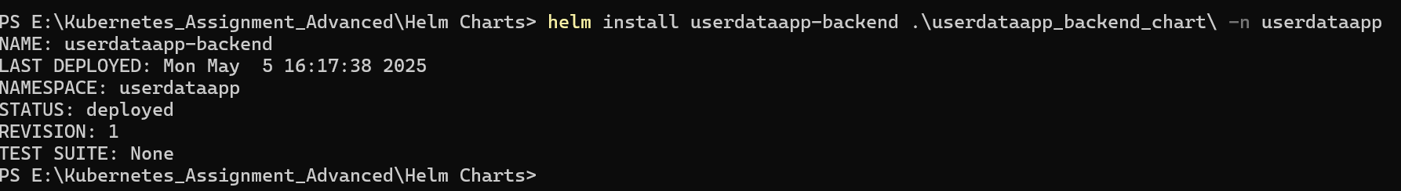

1. Check all resources created:

*> kubectl get all -n userdataapp*

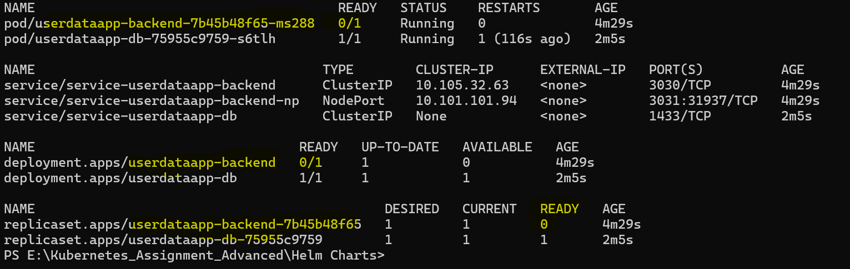

1. If backend resources are not in Ready state (as shown in above image). It might be because database script has not be executed in db container. We can do that manually:

*> kubectl exec -it po/* *userdataapp-db-75955c9759-s6tlh -n userdataapp -- /bin/bash*

*# /opt/mssql-tools18/bin/sqlcmd -S localhost -U sa -P $MSSQL_SA_PASSWORD -d master -i setup.sql -C*

**

1. Lets check all resources again:

*> kubectl get all -n userdataapp*

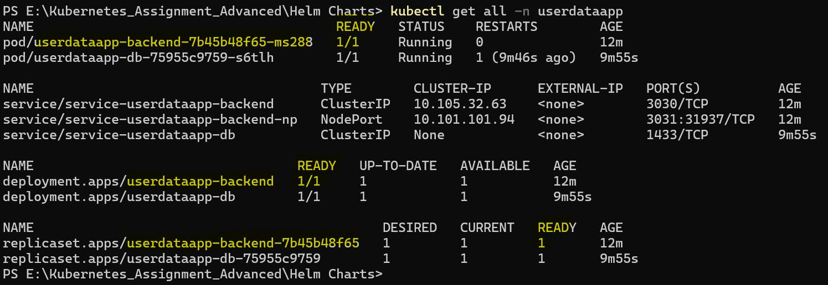

1. Let’s try running the service:

*> minikube service service-userdataapp-backend-np -n userdataapp*

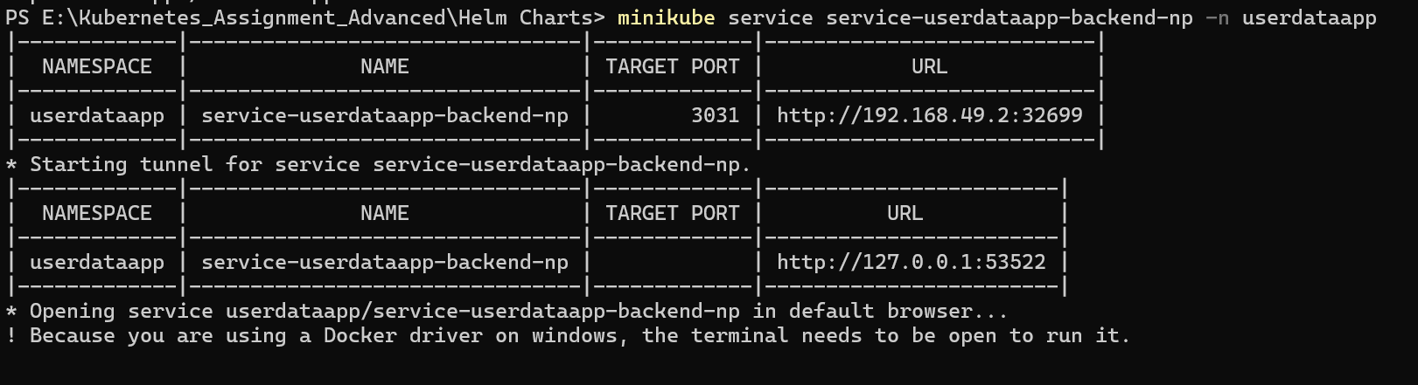

Default browser will get executed.

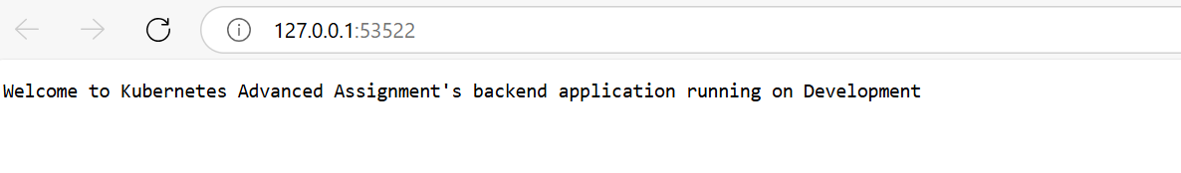

1. Pick the port “53522” and replace it in Postman http APIs and try APIs:

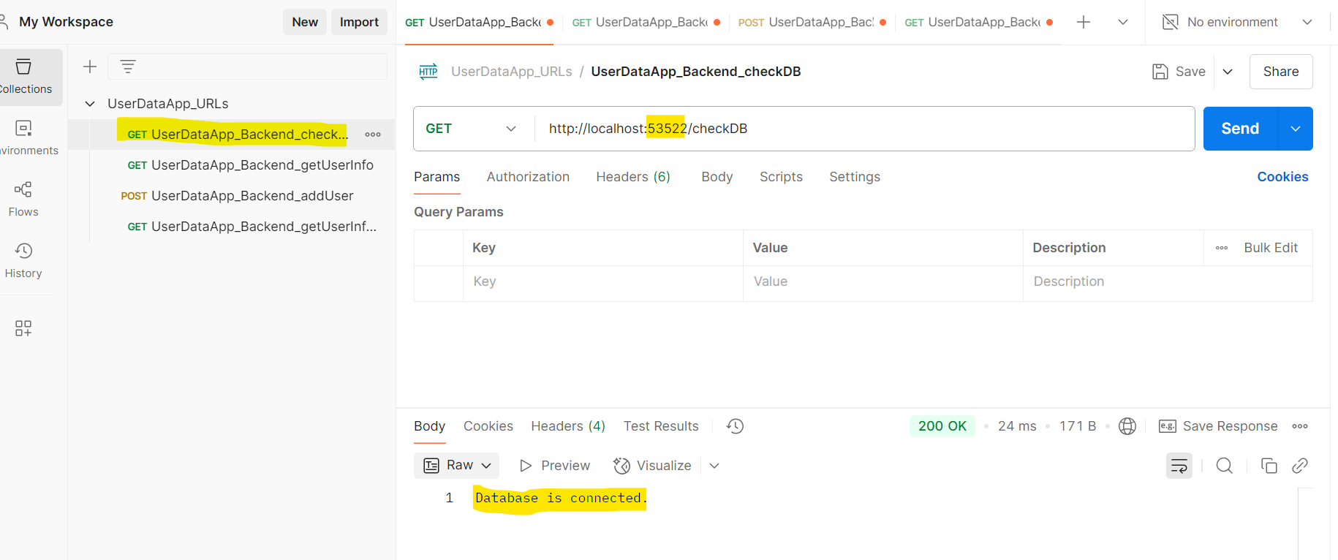

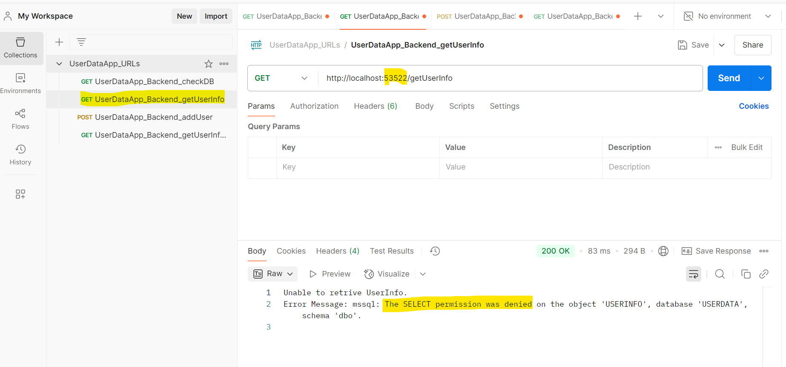

This error is because the user which we have used “userdataapp1” doesn’t have permission to Select. This user doesn’t have Insert, delete and update permissions also.

1. Let’s update values.yaml in “userdataapp_backend_chart”:
2. Uncomment "select: user2" (at line #35) in values.yaml of backend chart (/userdataapp_backend_chart/values.yaml) and comment "select: user1" (at line #34) then save it.

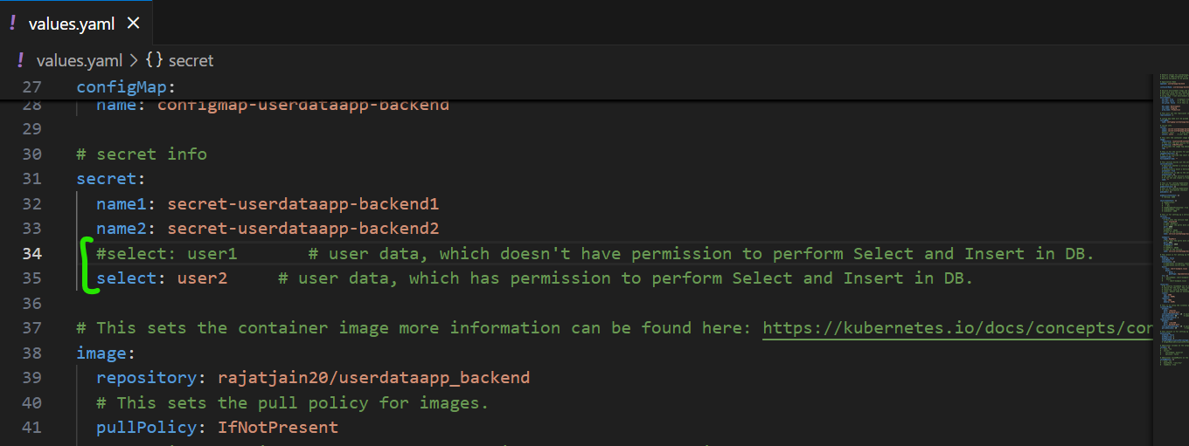

1. Upgrade the backend application using **helm upgrade:**

*> helm upgrade userdataapp-backend .\userdataapp_backend_chart\ -n userdataapp*

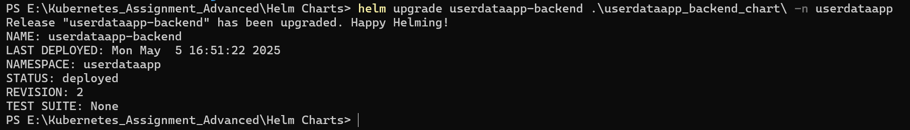

1. Test and verify http APIs again in Postman:

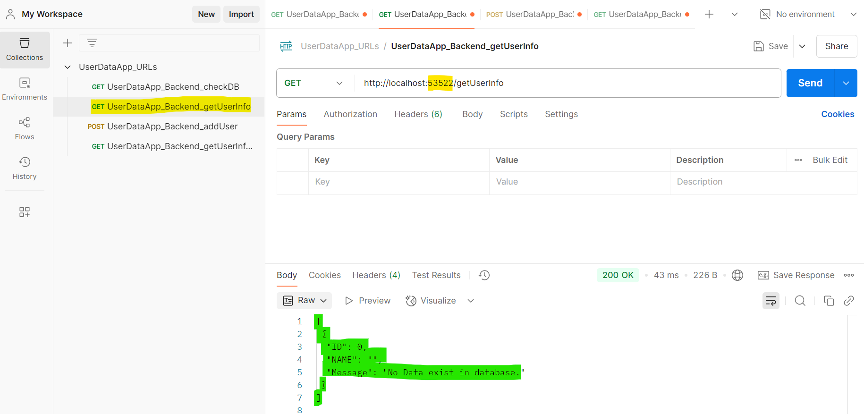

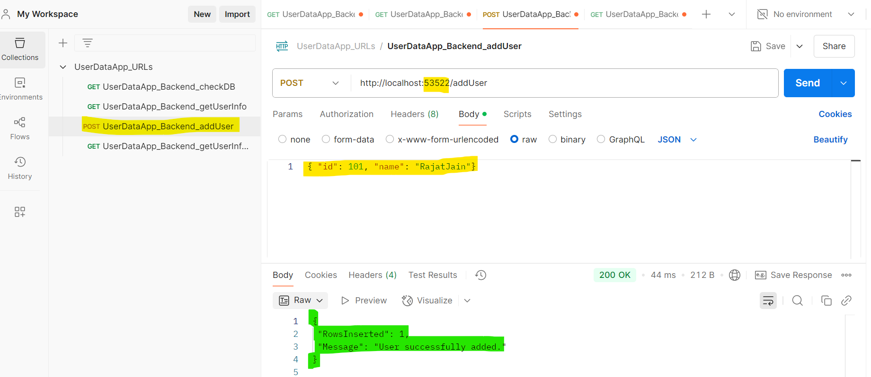

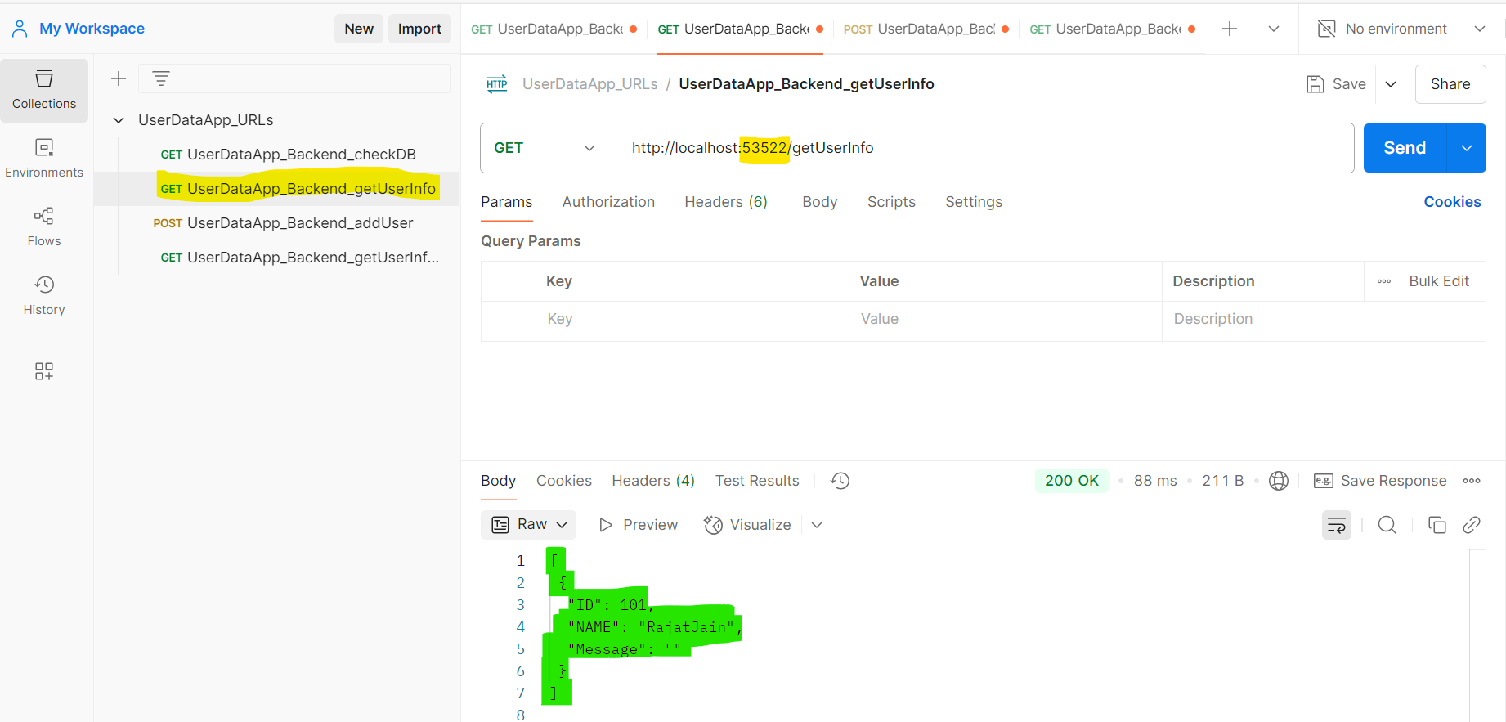

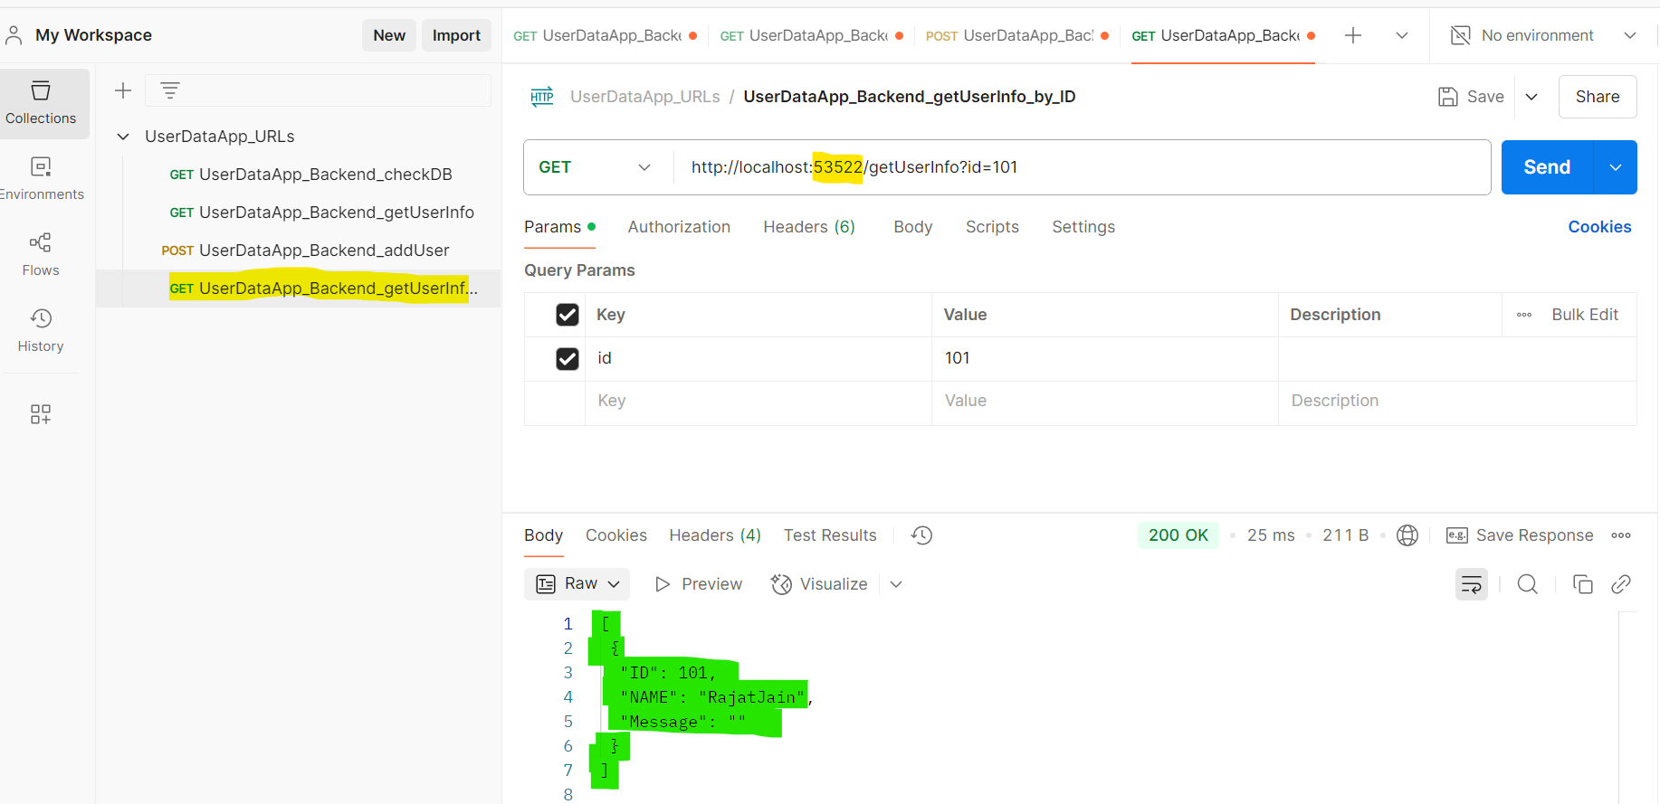

1. **Rollback** the backend application to the **latest previous revision** using below command:

*> helm rollback userdataapp-backend -n userdataapp*

**

1. Test and verify again on Postman (it should show permission issue again):

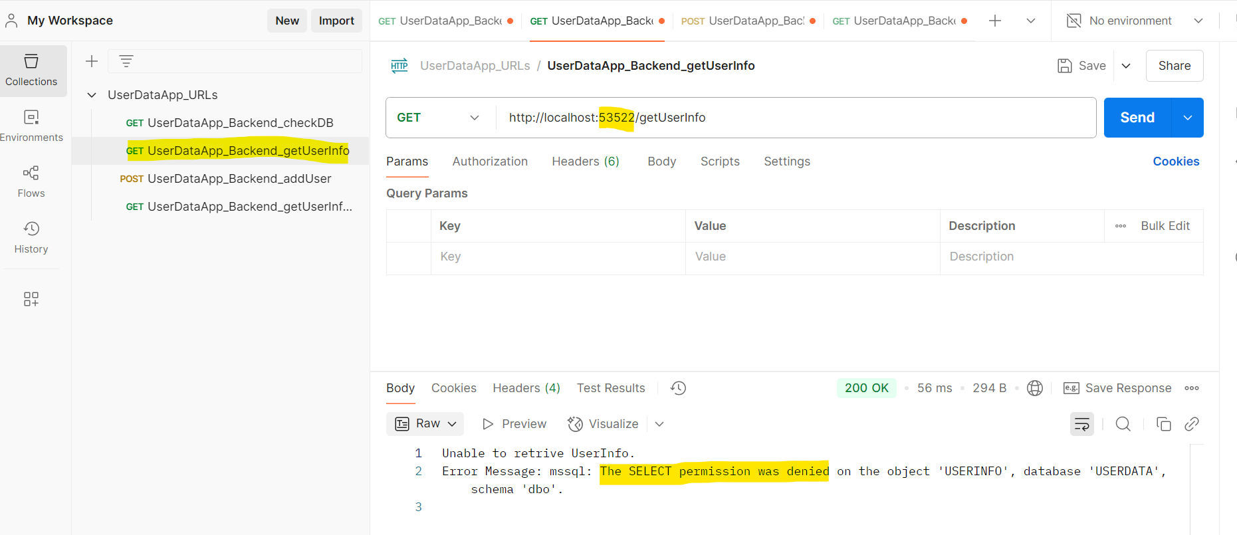

1. **helm revision history** can be seen using below command:

*> helm history userdataapp-backend -n userdataapp*

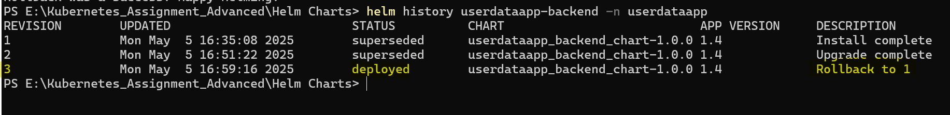

1. **Rollback** the backend application again to **a specific previous revision**:

*> helm rollback userdataapp-backend 2 -n userdataapp-dev*

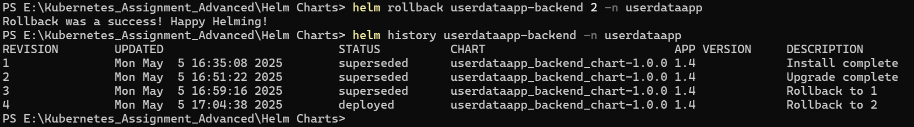

Now API will not show any permission issue.

**Note:** Detailedsteps and explanations are available in **ReadMe.md** file.